**Mini Review: Production and economics analysis of backyard production of Tiger grouper *Epinephelus fuscoguttatus* fingerlings in Situbondo, Indonesia**

Romi Novriadia

*a Directorate General of Aquaculture, Ministry of Marine Affairs and Fisheries, Republic of Indonesia*

*E-mail: Romi_bbl@yahoo.co.id*

**Abstract**

Application of backyard technology to produce tiger grouper fingerlings in the area of Situbondo is examined with emphasis on production system and economic structure. Complete hatcheries production system that employ full production systems from broodstock, maturation, spawning, larviculture and early nursery phase are common in this area. Natural spawning activities without the use of hormone or another chemical substance become the primary method to produce the larvae. Hatchery in Situbondo typically consist with concrete tank to culture the larva, sand filter and live food production tanks, including phytoplankton production system. While the nursery production system as an intermediate step between hatchery and grow-out production consist with concrete tank and grading system to reduce the size variation, cannibalism and to ensure there is no more than 30% difference in total length between the grade sizes within the culture tanks. The output of the economic analysis showed that with final survival rate about 10%, farmer in Situbondo still get a good annual return through the sales of fingerlings. From this situation, farmer still obtain high cash flow from backyard production system and about 69.06% rate of return to capital. Overall, backyard technology consists with hatchery and early nursery production system provide potential sources for poverty alleviation and support the sustainability of aquaculture production in Situbondo. Good economic structure and opportunity to participate in several government programs speed up the adoption of this technology and become an important chain for tiger grouper production system in Indonesia.

Keywords: *Backyard, Hatchery, Nursery, Economics, Tiger grouper, fingerling, Situbondo*

1. **Introduction**

The tiger grouper (*Epinephelus fuscoguttatus,* Forsskål, 1775) is an excellent mariculture species mainly due to its fast growth rate and high market prices (Apines-Amar *et al.* 2012, Ching *et al.* 2016). This species widely distributed in the indo-pacific region from the red sea and eastern Africa, as far east as Samoa and the phoenix islands, north to Japan and down to the south to Australia (Sugama *et al.* 2012, Rimmer and Glamuzina 2017). According to Sugama et al. (2012) tiger grouper is brownish-yellow to light brown in color and has an indentation in the head profile above the eye and a more deeply incised dorsal fin membrane. Specifically, this species further characterized by having 11 dorsal spines, 14-15 dorsal soft rays, 3 anal spines, 8 anal soft rays with small hexagonal spots on head, body becoming larger posteriorly and on vertical fins (Myers 1999), could achieves sizes at least 95 cm fork length (Heemstra and Randall 1993) and ages in excess of 40 years (Pears *et al.* 2006). Like other groupers, tiger grouper is a carnivorous and reported to have complex patterns of sexual development as a [protogynous hermaphrodite](http://www.arkive.org/brown-marbled-grouper/epinephelus-fuscoguttatus/#GlossaryTerm3) with reproductive life span of the female could exceed 30 years (Sugama et al. 2012, Pears et al. 2006, Pears *et al.* 2007).

Recently, FAO (2017) reported that 155,000 tonnes of groupers with a total value of USD 630 million produced and grown out in China, Taiwan Province of China and Indonesia as the major producer countries. In Indonesia, grouper aquaculture production, which is mainly located in Situbondo, has increased 5-fold within two decades and contribute around 11% to the global production (Yulianto *et al.* 2015, Rimmer and Glamuzina 2017). Stock enhancement into the natural populations and development of backyard hatchery become the key factors to the successful of grouper production this area (Sugama et al. 2012, Yulianto et al. 2015). Indeed, backyard hatcheries now making significant contributions to the farmers’ incomes, job opportunities and export earnings (Siar *et al.* 2001). Despite massive mortality at the early larval stage remains a foremost constraint to further improved the production (Ching *et al.* 2012), proper understanding on nutritional condition (Ching et al. 2016), sinking syndrome-related death (Fui *et al.* 2016), environmental quality (Toledo *et al.* 2004), cannibalism (Salari *et al.* 2012) and diseases infection (Sohn and Park 1998, Tucker 2003) become an important strategy for the fish farmer in Situbondo to increase the production efficiency and survival rate.

In this paper the comprehensive description related to the backyard production system together with the socio-economical survey of farming system producing the fingerlings of tiger grouper in the area of Situbondo – East Java, Indonesia are presented. The basic economic structure of backyard technology, including the initial investment, annual operating cost and income flows are computed to evaluate possible beneficial effects to produce tiger grouper fingerlings by using backyard technology system.

1. **Site location and Methods**

Primary Data for this study were obtained from backyard hatchery activities operated in Situbondo region, East Java, Indonesia from January to December 2019 and the seconder data were obtained from publish articles, scientific reports and journals. Other than known as marine shrimp production center, Situbondo also well recognized as the home of thousands backyard hatcheries for grouper production and successfully export millions of grouper seed to Taiwan, China and several South East Asian countries (Sugama 2010). There are two types of backyard system that commonly applied in Situbondo: (1) partial hatchery, this type of small-scale hatchery only focus on hatch and rear the fertilized eggs until reach the suitable size, and (2) complete hatcheries that employ full management systems from broodstock, maturation, spawning, live feed culture, fry production until market distribution (Siar et al. 2001).

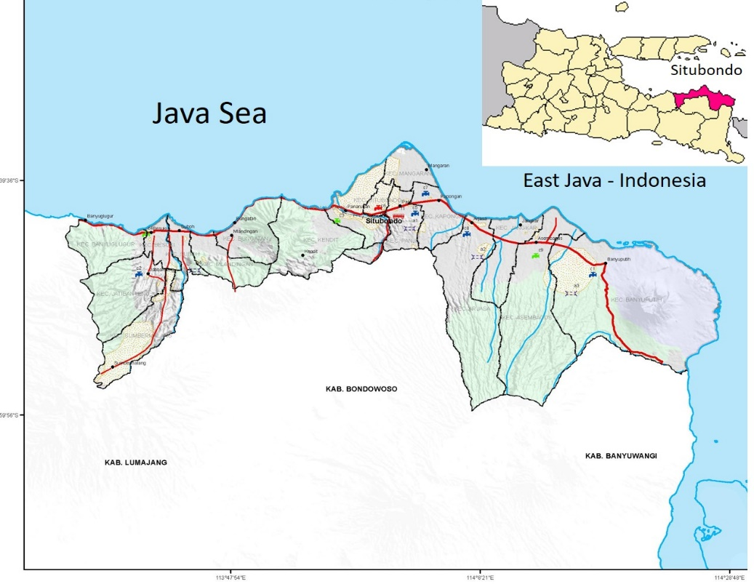

**Figure 1.** Map of Situbondo region, East Java, Indonesia

According to Boyd and Tucker (2012), in order to improve the efficiency of aquaculture production and reduce the risk of fish loss, knowledge on water quality is really important. For tiger grouper, recommended larval-rearing conditions to support an optimum growth are listed as follows: temperature at the range of 28 – 300 C, salinity: 32 - 34‰, dissolved oxygen: 80 – 100% saturation, light intensity: 500 – 700 lux, ammonia (NH3-N): <0.1 mg L-1 and nitrite (NO2-N): <1.0 mg L-1 (Sugama et al. 2012, Toledo et al. 2004). Based on the study from Kusumaningrum (2015) and Prakosa *et al.* (2013) water quality characteristics in Situbondo region fulfill these requirement, especially for larviculture production system. Other than water quality, knowledge on water budget to quantify optimum water requirement during the whole production cycle become increasingly important (Sharma *et al.* 2013). Proper plan and calculation will allow the increasing demand to produce more biomass per unit volume of water resources (Mohanty *et al.* 2009). Since all the water for aquaculture activities in Situbondo region coming from the coastline and available all year round without significantly affected by seasonal variation, farmer could use this benefit to maintain the sustainability of grouper fingerlings production.

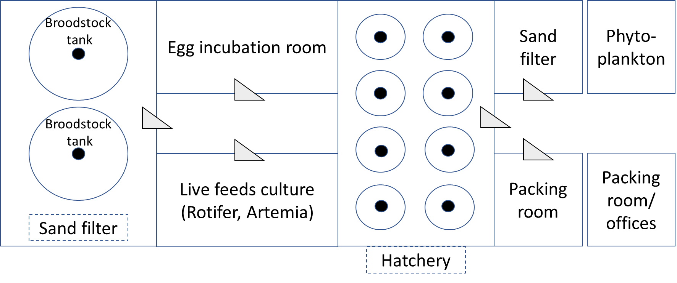

**Figure 2.** Modified layout from Sim *et al.* (2005) for a small scale hatchery with broodstock tank, egg incubation room, larval rearing tank, sand filter and live food production tank.

Small scale hatcheries for tiger grouper production in Situbondo typically consist with 2 to 8 larval rearing tanks made with concrete with capacity range from 6 to 10 m3, sand filter that consist with layer of coarse material and live food production tanks, including phytoplankton production with capacity vary from 10 m3 to 20 m3, rotifer production tank with capacity around 5 – 6 m3 and Artemia hatching tank with capacity range from 20 – 500 liters (Sim et al. 2005). All the system generally supported with flow-through water system and regular water exchange to avoid the degradation of water quality. Even though it is not common for backyard hatchery to produce their own larvae, some of the production center also own their broodstock facility to produce their own larvae equipped with egg incubation room. Moreover, it is important to acknowledge that the Indonesian government totally support the development of backyard hatchery by providing guidelines and technical services to the farmer (Febriana *et al.* 2013). The ongoing efforts from the government include the dissemination of applied technology, such as spawning and rearing technologies, development of cost-effective diet, laboratory services, and promoting growth of aquaculture in this region. Consequently, the synergistic work between government and local farmer provide widespread benefits to the coastal communities in this region (Siar et al. 2001).

1. **Farm management practices**

In this paper, the terms of “backyard” refer to the systems and activities of family in Situbondo area consist with broodstock management activities, hatchery and early nursery phase to produce tiger grouper fingerlings with average length around 8 – 9 cm or known as complete hatchery system with profit-making purposes.

3.1 Broodstock management

To date, considerable amount of research on captive breeding technologies including broodstock management of tiger grouper has been done to produce high quality larvae (Ali *et al.* 2006, Sim et al. 2005). In common with many producer countries, broodstock collection largely depend on the wild-caught activities (Cesar *et al.* 2000). Because of this dependence, the larvae production will heavily rely on the mature condition (Ali et al. 2006) and required knowledge on specific nutrition requirement of the tiger grouper broodstock (Sugama et al. 2012). In addition, as a hermaphrodite protogyny animals that can changes the sex from female into male, additional knowledge on captive conditions could avoid any failure in sex reversal and maturity (Ali et al. 2006). Based on this situation, breeding management is important to ensure the production efficiency and sustainability.

In Situbondo, it is common to apply the circular tank to maintain the broodstock with size varies depends on the size and swimming activities of the broodstock. Prior to stocked the broodstock into the tanks, fish were placed into the quarantine tank and checked for the health status to avoid any diseases transmission to the culture environment. The broodstock tank equipped with overflow pipe and nets for egg collection purposes. Each system supported by sand filter to maintain the water quality within the acceptable range for grouper. In addition, farmer also control the natural photoperiod to maintain water temperature and salinity at the level of 27 to 310C and 32 to 34 ‰, respectively. As suggested by Sugama et al. (2012), in Situbondo, tanks also roofed to avoid massive growth of algae on the walls, to avoid the difficulties in eggs collection and minimize the parasite infestation.

Depend on the availability of broodstock, to induce the natural spawning activities in the tanks, a ratio of 1 male to 5 females are commonly employed. To check the sex of individual fish, physical examination by gently massaged in a head-to-tail direction were recommended following the protocol described by Sugama et al. (2012). Based on the field observation, a sexually ripe male will extrude copious milt from its urinogenital pore, while female will be identified as the eggs obtain from the genital pore via cannulation process. Natural spawning activity generally occurs during the night between 22.00 PM to 03.00 AM for three to six nights each month during the new moon phase and may spawn around 0.6 to 0.8 million eggs per night (Sugama et al. 2012). Floating eggs range from 0.8 to 0.9 mm in diameter were considered as the good size to be harvested prior to transferred into the egg incubation tanks.

For the successful of broodstock management, an understanding about the nutritional requirement also become the main key to control the reproductive cycle. Since there is no specific diet to the broodstock, transglutaminase-based “sausage” feed supplemented with vitamin mixes and delivered to satiation six times each week normally applied by the farmer in Situbondo.

|  |  |
| --- | --- |
| **Ingredients (g kg-1 as is)** | **Amount (g)** |
| Commercial feed with crude protein > 40% | 150 |
| Fresh fish (sardines, mackerel, etc.) | 600 |
| Squid | 50 |
| Transglutaminase B | 10 |
| Rice flour or starch | 185 |
| Trace Mineral premix | 2.5 |
| Vitamin premix w/o choline | 2.5 |
| Total | 1 kg |

**Table 1.** The composition of transglutaminase-based “sausage” feed for tiger grouper broodstock modified from Sugama et al. (2012)

* 1. Egg incubation procedures

Prior to being transferred to the incubation tank, eggs were cleaned and disinfected with sterile sea water and ozone treatment to minimize the chance for vertical transmission of pathogen, such as betanodavirus as the causative agent of Viral Nervous Necrosis Virus (Buchan *et al.* 2006). The eggs were incubated under very clean and optimal condition with stocking density around 400 eggs/liter (Toledo et al. 2004). During the incubation period, constant aeration at the rate of 100 mL min-1 were provided and dissolved oxygen, temperature and pH were maintained at the range of 5.0 – 6.0 mg L-1, 30 – 320 C, and 7.5 – 8.2, respectively (Sugama et al. 2012, Chu *et al.* 2016). In terms of salinity at the incubator, based on the study conducted by Chu et al. (2016), level of 30 ‰ is considered as the optimum incubation condition to avoid any abnormal appearances and significant decrease of hatching rate.

The evaluation of egg quality is very important to avoid poor-quality larvae during the larviculture period. Thus, several indicators for eggs, including the shape, cells size, transparency and embryos, and the presence of parasites or any fouling organisms especially at the chorions or the egg shells are become the important evaluation parameters. As suggested by Sugama et al. (2012) if there is high proportions of eggs (> 10%) that are irregularly shaped, dark or with aberrant embryonic development, the batch should be discarded. Depends on temperature, time to hatching and the duration of hatching period may take around 20 – 24 hours.

* 1. Larval rearing

Larviculture normally carried out in indoor hatchery systems using both round and rectangular tanks made from concrete with average capacity around 10 m3 and depth around 1.2 m. Particularly for the rectangular tanks, the corner of the tanks should be rounded to avoid larval aggregation in the corners of the tank (Sugama et al. 2012). There are three important points that need to be addressed during the larviculture period: (1) water management, (2) feed management and (3) health management practices. For water management practices, static water system will be applied from stocking day until 7 days after hatching (DAH) (Fig 3). To avoid any extreme change in terms of water quality condition during the larviculture period, initial water exchange need to be limited to only 10% per day at 7 – 12 DAH. With the addition of Artemia nauplii from 10 DAH and microencapsulated diet at 12 DAH, the water exchange rate need to be increased up to 20% during the first week and gradually increase up to 50% at the final week of larviculture period to maintain the water quality (Fig 3). Following the protocol described by Sugama et al. (2012) from about 12 DAH, any debris or uneaten food accumulating on the bottom need to be siphoned each day. Moreover, it is advisable to stock the grouper to the hatchery tank at the eyed stage just before hatching, because the newly hatched larvae will be very sensitive to physical shocks or changes in water quality from the incubation tanks to the hatchery tanks (Sugama et al. 2012). Recommended stocking density for hatchery stage is 10 larvae per liter. From this number, with tank capacity around 10 m3, expected number of fingerlings that can be harvested and transferred to nursery tanks is around 20,000 fingerlings.

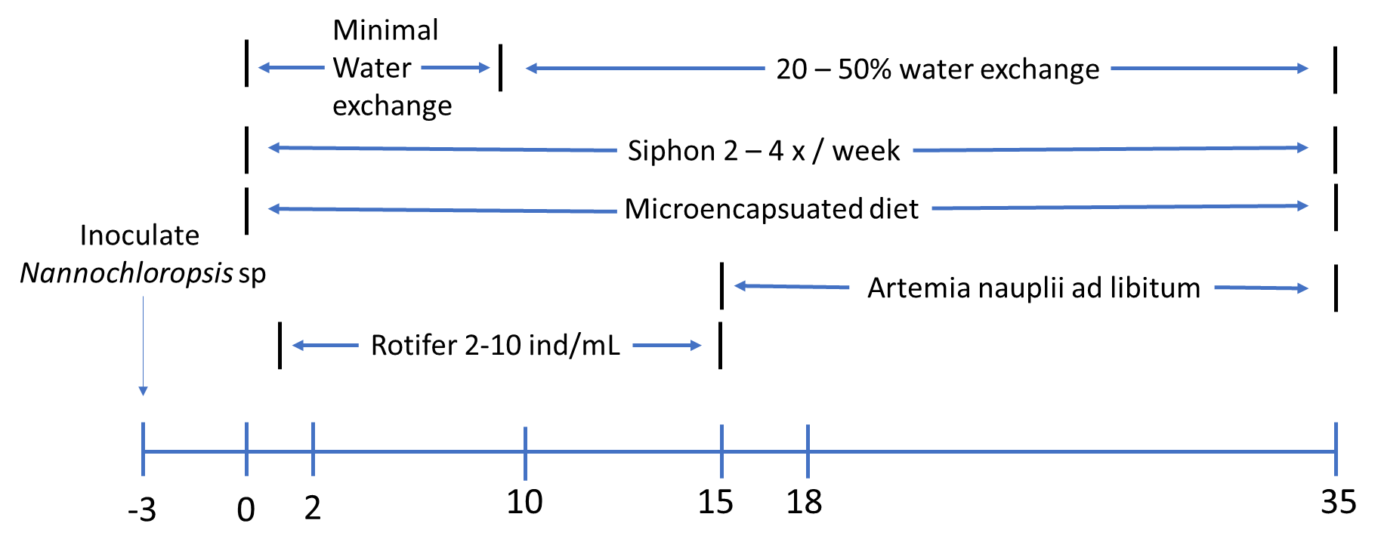

**Figure 3.** ModifiedFeeding and water management system from Toledo *et al.* (1999) for small scale hatchery using green water system for production of tiger grouper fry.

With regard to water quality, recommended values for physico-chemical parameters for tiger grouper larviculture are described as follows: temperature at the range of 28 – 300 C, salinity 32 – 34 ‰, dissolved oxygen at 80 – 100% saturation, ammonia < 0.1 mg L-1, Nitrite < 1.0 mg L-1, light intensity 500 – 700 lux and maintained under natural photoperiod (Toledo *et al.* 2002, Sugama et al. 2012). During larviculture period, the major concern for water quality is the level of temperature within the rearing tank. As indicated by De *et al.* (2016) change in temperature will have a significant negative impact on growth performance and gastric emptying rate. Moreover, change in temperature also induce the virulence factor of betanodavirus as the causative agent for viral nervous necrosis and nitrification rate in culture environment (Sugama et al. 2012, Weon *et al.* 2004). To overcome this issue, the application of heater or cooler is required to provide better control of water temperature.

Feeding regime during larviculture need to consider the relatively short yolk sac absorption period and small yolk sac of tiger grouper upon hatching (Kohno 1998), resulting an urgent need for nutritional transition from yolk sac to exogenous feeding (Fyhn 1989). Consequently, larvae are highly vulnerable to starvation when the exogenous feeding are not administrated at the proper time and quantity. Study from Ching et al. (2012) suggested that first exogenous feeding for grouper larvae should commence at 0 h after the mouth opening stage to enhance the larval survival and growth. Based on this situation, proper feed management will be applied by providing zooplankton, such as enriched rotifer and artemia in combination with microencapsulated diet under green water system technique with various weaning strategy (Fig 3). Sugama et al. (2012) suggested that adding microalgae *Nannochloropsis oculata* at the density of 500 x 103 to 100 – 500 x 106 3 days before stocking the larvae would contribute to the management of water quality, shading effect and direct food sources for live prey organisms added to the tank (Rimmer 2000). Even though the nutritive value from ingested microalgae to the larvae is still unknown, the application of green water system has also been shown to improve the larval growth and survival (Su *et al.* 1998).

Generally, the mouth of groupers larvae will be opens at 2 – 3 DAH (Rimmer 2000), and the larvae begin feeding soon thereafter with small size particles, such as small type of rotifers *Brachiounus* spp (Lim 1993, Watanabe *et al.* 1996). According to Sugama et al. (2012) high mortality usually occur at the first week of feeding period due to the unsuitable size of rotifers provided. Based on this situation, regular checks to ensure the administration of appropriate size and density of live food for the larvae need to be performed. According to Tamaru *et al.* (1995) optimal density of rotifer during the early larval stages is 10 – 20 organisms mL-1. Since grouper larvae have a very high requirement for dietary docosahexaenoic acid (DHA), various commercial supplementation could be used for nutritional enhancement, such as mixed algal diet, taurine-enriched rotifers and several type of spray-dried whole cells (Alava *et al.* 2004, Park *et al.* 2006, Hawkyard *et al.* 2016, Thépot *et al.* 2016). In addition, the application of mixed microalgae to promote the green-water system not only provides the fish larvae with a more shaded environment, it also provides a complete profile of essential fatty acid, including docosahexaenoic acid (DHA), eicosapentaenoic acid (EPA) and arachidonic acid (ARA) (Thépot et al. 2016).

For marine fish, several authors acknowledge the importance of weaning strategy from rotifer to the larger size of live food, such as the brine shrimp *Artemia salina,* to fulfill the nutritional requirements of the larvae (Denson and Smith 1996, Baskerville-Bridges and Kling 2000, Davis *et al.* 2005). In Situbondo, Artemia were added as a supplement to the rotifer at 10 DAH at a density of 0.1 individual mL-1 and then increased into 0.5 individual mL-1 when artemia totally replace the addition of rotifer at 15 DAH. Depend on the growth performance, the density of Artemia could be increased to 1 individual mL-1 at 25 to 30 DAH. Following the recommendation from Sugama et al. (2012) supplementation with several commercial products to increase the fatty acid level in brine shrimp also performed by the farmer. However, since Artemia quite costly and variable in their nutrition profile, early weaning onto the micro-encapsulated diet become the favorite strategy.

3.4 Nursery culture

Nursery culture system is an intermediate step between hatchery and grow-out production. For backyard technology, nursery also become the final step before reach the market size for fingerlings. As mentioned earlier, the initial size for nursery system usually around 2 – 3 cm obtained from the hatchery system and then being cultured until they reach the harvest size of 8 – 9 cm. Depend on nursing system, the stocking density of fish with average size around 2.5 – 4 cm in tanks system will be around 1,000 – 1,500 fish/m3 and 1,500 – 2000 fish/m3 for fish being cultured in floating net cages (Ismi *et al.* 2012). To avoid any diseases outbreak, it is recommended to carefully checked the health status of the fish and ensure they are free from parasites before stocked in the nursery system. If the nursery needs to be integrated with hatchery, proper biosecurity program needs to be performed to avoid any diseases transmission.

With regards to water management, continuous circulation system with a minimum of 300% water exchange per day are recommended. To avoid stress, water current need to be adjusted to avoid any backwards flow or condition where fish have to swim excessively against the water current (Ismi et al. 2012). Stress condition will lead to the immunosuppression effect and make fish become more vulnerable to the diseases infection (Leatherland and Woo 2010). Recommended values for physico-chemical parameters for nursery culture are described as follows: temperature at the range of 25 – 320 C, salinity 30 – 32 ‰, dissolved oxygen 4 – 8 mg L-1, pH 7.5 – 8.3 and unionized ammonia less than 0.02 mg L-1 (Ismi et al. 2012).

In terms of feeding regime, various type of feed could be used, including dry (commercial) diets, moist pellets and combinations trash fish. Since trash fish can be a source of pathogen, especially betanodaviruses (Gomez *et al.* 2010), farmer in Situbondo normally use the dry diets contain with optimum nutritional requirement for tiger grouper juvenile production. Detail for dietary composition during the nursery culture system are summarized in Table 2.

|  |  |
| --- | --- |
| **Composition** | **Recommended value** |
| Protein | 50 – 52% dry matter basis |
| Lipid | < 12 – 13% dry matter basis |
| Protein: energy ratio | 30 g crude protein: 1 MJ gross energy |
| n-3 HUFA | >1% |
| DHA | >0.75% |
| Ascorbic acid | 50 mg kg-1 ascorbic acid equivalent as a heat-stable product |

**Table 2.** Nutrient composition for juvenile (< 20 g) grouper adopted from Williams (2009)

Following the trend in aquaculture to develop more sustainable and economically-sound practical diet, the application of plant-based diet has been considered. To minimize the effects of anti-nutrients due to the use pf plant-protein sources, diet supplemented with phytase become the main preference in this area. In order to enhance the palatability and efficacy of plant-based diet, several attractants also added by the farmer into the diet

|  |  |  |  |
| --- | --- | --- | --- |
| **Fish size (g)** | **Daily feeding rate (% BW)** | **Crude protein (%)** | **Number of feeds/day** |
| 1 – 5 | 4.0 – 10.0 | 50 – 52 | 3 – 5 |
| 5 – 20 | 2.0 – 4.0 | 50 – 52 | 2 – 3 |
| 20 – 100 | 1.5 – 2.0 | 48 – 50 | 2 |
| 100 – 200 | 1.2 – 1.5 | 48 – 50 | 1 – 2 |
| 200 – 300 | 1.0 – 1.2 | 45 – 48 | 1 |
| >300 | 0.8 – 1.0 | 40 - 45 | 1 |

**Table 3.** Recommended feeding practices and crude protein (%) with dry pellet modified from Sim et al. 2005)

Regarding to feed management practices, pellet size and daily feeding rates typically adjusted based on the growth of the fingerlings. In Situbondo, as the length and mouth size of juvenile increases, the pellet size will be increases. However, as the growth of juvenile increases, daily feeding rate (% body weight) and number of feeding per day need to be decrease. Considering the feeding activities, early morning feeding normally applied since it will significantly reduce the cannibalism among the fish compared to feed the juvenile later in the morning (Ismi et al. 2012).

In nursery production system, other than VNN outbreaks, cannibalism become the main concern and cause massive mortality during the culture period. There are three main strategy that commonly employed in Situbondo: (1) proper stocking density based on the size of the fish, (2) regular grading activities to ensure that each tank will held similar size of fish, and (3) feed management to control the appetite. As suggested by Ismi et al. (2012) the density need to be reduced as the fish grow bigger. Table 4 will provide detail information on recommended stocking density for tiger grouper juvenile reared in tanks system until they reach the harvest size.

|  |  |
| --- | --- |
| Total length (cm) | Density (no. fish per m3) |
| 2.5 – 4 | 1,000 – 1,500 |
| 4 - 5 | 750 – 1,000 |
| 5 – 7 | 500 – 750 |
| 7 – 9 | 400 – 500 |
| 9 - 11 | 300 - 400 |

**Table 4.** Recommended stocking density of tiger grouper juvenile reared in tank system.

Grading system is the common method in Situbondo to reduce the size variation and cannibalism. In addition, grading system also important to ensure there is no more than 30% difference in total length between the grade sizes within the culture tanks (Hseu *et al.* 2007). However, it is important to note that the unproper grading technique on smaller fish will generate another problem as it will cause damage to the fish and fish become more susceptible to diseases infection. Thus, any fish showing signs of infected, swimming slowly, or with other abnormal behavior after the grading activities need to be discarded from the tank. There are two types of graders that normally used, namely: bar graders and mesh graders. Each of the graders has their own advantage and disadvantage. Considering the health status of the fish after the grading activities, bar graders are preferred to mesh graders for fish >1 cm (Ismi et al. 2012).

When the fingerlings reach the market size, fish reared in concrete tanks will be harvested by seine in the early morning or late afternoon. Feeding need to be stopped one day before harvest to avoid any stress condition during the harvest. For fish cultured in floating net cages, net need to be inspected for any damage and then lifted to one side to concentrate the fish in one corner. For harvest purposes, a fine and knotless scoop or soft plastic screen could be used to avoid any loss on scales or causing lesions during harvest (FAO 2010). After harvest, live fish trading becomes the only choice in Situbondo to increase the profit margin. Basically, there are two types of live fish transport for small fingerlings (2 – 3 cm in length) and nursery size (8 – 9 cm in length): open system which uses live fish tanks that involves all necessary factors to meet the grouper’s requirement for survival, and close system which used plastic bag filled with oxygen to pack the fish (Lim *et al.* 2007).

3.5 Diseases management

Despite the success in the development of culture management for grouper backyard hatchery, the viral disease known as viral nervous necrosis (VNN) causes substantial impact to the survival of larvae (Rimmer *et al.* 2004), including in Situbondo production center. Affected fish normally showed clinical symptom of anorexia, disorientation in swimming behavior, dark coloration and vertebral deformity (Sohn and Park 1998, Sugama et al. 2012). Moreover, histological and microscopic examinations reveal the presence of heavy vacuolation of the retina, brain, and spinal cord tissue due to the infection (Sugama et al. 2012). The causative agent of VNN identified as a non-enveloped bi-segmented single strand positive-sense RNA virus with sizes from 25 – 30 nm and belong to the Nodaviridae family (Chi *et al.* 1999). If the outbreak of VNN occurs, strict quarantine needs to be performed and no transfer of fish or equipment between affected and unaffected tanks. For severe outbreaks, farmer in Situbondo kill all the infected fish and destroy all the infected equipment to avoid any chance for diseases transmission to other culture unit. Currently, there are no effective treatment for VNN infection (Yanong 2010). Thus, depopulation followed by several prophylactic and prevention treatments were performed by the farmer.

Vaccination become the primary strategy to induce the immune system of fish in tiger grouper production system. Vaccine were provided to the healthy animals prior to diseases outbreak in order to allow the development of “memory” and response in later infections (Yanong 2011). Other than vaccine, temperature control and biosecurity program were normally applied to prevent the VNN outbreaks. Lower temperature than 30 – 320 C will not cause any cell necrosis or mortality to the larvae and strict regulation on the use of equipment may become the best defense for VNN outbreaks (Chi et al. 1999, Sugama et al. 2012). lastly, strict quarantine policy and the use of specific pathogen free (SPF) larvae become the main strategy to avoid any diseases transmission and production failure.

1. **Enterprise budget**

High economic value of tiger grouper fingerlings become the primary motivator for the fish farmer in Situbondo. Moreover, low capital investment and production cost of backyard production system also become another consideration for many farmers or investor with limited capital to involves in this system. To understand the economic structure of backyard technology, the following table will describe the capital investment, annual expenses and annual income to produce the fingerlings with average size about 8 – 9 cm in total length (Table 5). The economic component will be based on the actual prices and condition in Situbondo and an exchange rate of IDR 13,000 to USD 1 will be used. Below are several assumptions used in this economic analysis:

1. Two production cycle per year
2. The real value of land is stable over the life of the project
3. Taxation was excluded from all calculations
4. 150,000 viable eggs with 50% survival in hatchery (8-9 cm)
5. Market price for one fingerling with size of 8 – 9 cm is USD 0.8
6. The amount of artificial diet in hatchery and early nursery phase was calculated based on food conversion ratio (FCR) of 1.4 and with 6% body weight when the fingerlings at size of 1 – 5 g and then reduces to 3 % when the fingerlings almost reach the harvest size 8 – 10 g.

$$Amount of feed=\left(average weight*no. of fish\right)*\% body weight$$

|  |  |  |  |  |
| --- | --- | --- | --- | --- |
| **No** | **Component** | **Unit** | **Cost per unit (USD)** | **Total cost (USD)** |
|  | **Capital investment** | | | |
| 1 | Broodstock tank | 2 | 3,000 | 6,000 |
| 2 | Microalgae tanks | 2 | 2,000 | 4,000 |
| 3 | Rotifer tanks | 2 | 1,500 | 3,000 |
| 4 | Incubation tanks | 6 | 300 | 1,800 |
| 5 | Artemia hatching jar | 2 | 200 | 400 |
| 6 | Larval tanks | 2 | 2,000 | 4,000 |
| 7 | Early nursery tanks | 4 | 2,500 | 10,000 |
| 8 | Power installation | package | 500 | 500 |
| 9 | Emergency generator set | 1 | 500 | 500 |
| 10 | Air blowers - 100 watt | 1 | 800 | 800 |
| 11 | Submersible pump | 3 | 100 | 300 |
| 12 | Sea water pump | 3 | 150 | 450 |
| 13 | Sand filter | 4 | 250 | 1,000 |
| 14 | PVC piping | package | 1,000 | 1,000 |
| 15 | Miscellaneous |  |  | 1,000 |
|  | **Total capital investment** |  |  | 34,750 |
|  | **Operating expenses** | | | |
| 1 | Small type rotifer | 10 | 30 | 300 |
| 2 | Brine shrimp Artemia salina | 5 | 50 | 250 |
| 3 | Rotifer and artemia enrichment product | 10 | 50 | 500 |
| 4 | Broodstock | 10 | 100 | 1,000 |
| 5 | Microencapsulated diet | 50 | 10 | 500 |
| 6 | Artificial diets for nursery | 150 | 10 | 1,500 |
| 7 | Chemicals and fertilizers | package | 2,000 | 2,000 |
| 8 | Gasoline and fuel | package | 4,000 | 4,000 |
| 9 | Electricity | package | 200 | 200 |
| 10 | Insurance | package | 500 | 500 |
| 11 | Hired labor | 2 | 200 | 400 |
| 12 | Annual certification | package | 150 | 150 |
| 13 | Land lease per year | package | 500 | 500 |
| 14 | Miscellaneous |  |  | 1,000 |
|  | **Total annual expenses** |  |  | 12,800 |
|  | **Total investment and expenses** |  |  | 47,550 |
|  | **Farm annual sales** |  |  |  |
| 1 | fingerlings (8-9 cm) per cycle | 15,000 | 0.8 | 12,000 |
| 2 | Income per year (2 cycle) |  |  | 24,000 |
|  | **Total income** |  |  | 24,000 |
|  | **Net farm income** |  |  | 11,200 |
|  | **Rate of return to capital** |  |  | 69,06 % |

**Table 5.** Economic analysis of tiger grouper fingerling production using backyard technologies

The majority of tiger grouper fingerlings reared in Situbondo area are sold domestically to a number of grow-out producer or exported to other countries, such as Malaysia, Singapore and Philippines. Here, brokers play a role in trading the grouper fingerlings and sometimes considered as an intermediate buyer. In this economic analysis, packaging and transportation were not included since normally, the broker would pick up the fingerlings and cover all the packaging, freight and transportation cost to the destination places. As mentioned by Siar et al. (2001) the primary challenge to establish the economic analysis for backyard production is the variability in market price. This mainly due to most of the farmer in Situbondo act as a price taker, accepting whatever the market offers to them.

The output of the summary shows the actual cost for investment, annual production cost, gross revenue for the backyard production system, net income and rate return to the capital. Given that the total annual expenses to produces the tiger grouper fingerlings around USD 12,800, the annual gross income from this production system for two production cycle in a year is quite good. From 150,000 viable eggs stocked into the hatchery tanks and with final survival rate about 10%, we still get a good annual return through the sales of fingerlings. From this situation, we as the producer could get high cash flow from backyard production system and about 69.06% rate of return to capital. This is in line with backyard technology to produce tiger grouper fingerlings in Bali, where the quick turnover (2 – 3 months) provides a high rate of cash flow only through the hatchery system (Siar et al. 2001).

1. **Conclusion**

Backyard technology consist with hatchery and early nursery production system provide potential sources for poverty alleviation and support the sustainability of aquaculture production. Good economic structure and opportunity to participate in several government programs may speed up the adoption of this technology and become an important chain for tiger grouper production system in the area of Situbondo, East Java, Indonesia.

**References**

Ali, H. M., Om, A. D., Idris, S. M., Mustafa, S. & Neng, T. P. 2006. Improved Artificial Breeding Techniques of Tiger Grouper (Epinephelus fuscoguttatus). Pages 1-12*.* 4th National Fisheries Symposium: Advancing R&D towards¢ fisheries business opportunities.

Apines-Amar, M. J. S., Amar, E. C., Faisan Jr, J. P., Pakingking Jr, R. V. & Satoh, S. 2012. Dietary onion and ginger enhance growth, hemato-immunological responses, and disease resistance in brown-marbled grouper, Epinephelus fuscoguttatus. Aquaculture, Aquarium, Conservation and Legislation 5**:** 231-239.

Boyd, C. E. & Tucker, C. S. 2012. Pond aquaculture water quality management*,* Springer Science & Business Media.

Cesar, H. S., Warren, K. A., Sadovy, Y., Lau, P., Meijer, S. & van Ierland, E. 2000. Marine market transformation of the live reef fish food trade in Southeast Asia. Collected essays on the economics of coral reefs**,** 137-157.

Ching, F. F., Nakagawa, Y., Kato, K., Miyashita, S. & Senoo, S. 2016. Effects of delayed first feeding on nutritional condition of tiger grouper, Epinephelus fuscoguttatus (Forsskål, 1775) larvae. Aquaculture Reports 3**:** 225-228.

Ching, F. F., Nakagawa, Y., Kato, K., Murata, O. & Miyashita, S. 2012. Effects of delayed first feeding on the survival and growth of tiger grouper, Epinephelus fuscoguttatus (Forsskål, 1775), larvae. Aquaculture Research 43**:** 303-310.

FAO. 2017. FishStatJ, a Tool for Fishery Statistics Analysis. FAO Fisheries and Aquaculture Department, FIPS - Statistics and information, Rome

Febriana, A. D., Sugiono, S. & Yuniarti, R. 2013. Evaluasi Struktur Supply Chain Pendistribusian Benih Dan Budidaya Ikan Terhadap Profit Supply Chain Dengan Pendekatan Simulasi Sistem Dinamik (Studi Kasus: Hatchery Ikan Kerapu Di Situbondo). Jurnal Rekayasa dan Manajemen Sistem Industri*,* 1**,** p275-285.

Fui, C. F., Miura, A., Nakagawa, Y., Kato, K., Sakamoto, W., Takii, K., Miyashita, S. & Senoo, S. 2016. Aeration rate adjustment at night to prevent sinking syndrome‐related death in the tiger grouper Epinephelus fuscoguttatus (Perciformes: Serranidae) larvae. Aquaculture Research 47**:** 165-175.

Heemstra, P. C. & Randall, J. E. 1993. FAO species catalogue vol. 16 groupers of the world (family serranidae, subfamily epinephelinae): An annotated and illustrated catalogue of the grouper, rockcod, hind, coral grouper, and lyretail species known to date*,* Food and Agriculture Organization of the United Nations.

Kusumaningrum, I. 2015. Coast environment conservation by home scale grouper culture in Pecaron-Situbondo. Journal of Aquaculture Research and Development*,* 6.

Mohanty, B., Mal, B., Sharma, K. & Mohapatra, B. 2009. Water requirements of a portable FRP carp hatchery for Rohu spawning and eggs hatching. Fishing Chimes29**:** 47-49.

Myers, R. 1999. Micronesian reef fishes: a comprehensive guide to the coral reef fishes of Micronesia, 3rd revised and expanded edition. iCoral Graphics. Barrigada, Guam.

Pears, R., Choat, J., Mapstone, B. & Begg, G. 2007. Reproductive biology of a large, aggregation‐spawning serranid, Epinephelus fuscoguttatus (Forsskål): management implications. Journal of fish biology 71**:** 795-817.

Pears, R. J., Choat, J. H., Mapstone, B. D. & Begg, G. A. 2006. Demography of a large grouper, Epinephelus fuscoguttatus, from Australia’s Great Barrier Reef: implications for fishery management. Marine Ecology Progress Series*,* 307**,** 259-272.

Prakosa, D. G., Kusuma, W. E. & Pramujo, S. S. 2013. Pembenihan ikan kerapu tikus (Cromileptes altivelis) di instalasi pembenihan Balai Budidaya Air Payau (BBAP) Situbondo, Jawa Timur. Jurnal Ilmu Perikanan 4**:** 67-75.

Rimmer, M. A. & Glamuzina, B. 2017. A review of grouper (Family Serranidae: Subfamily Epinephelinae) aquaculture from a sustainability science perspective. Reviews in Aquaculture.

Salari, R., Saad, C. R., Kamarudin, M. S. & Zokaeifar, H. 2012. Effects of different stocking densities on tiger grouper juvenile (Epinephelus fuscoguttatus) growth and a comparative study of the flow-through and recirculating aquaculture systems. African Journal of Agricultural Research 7**:** 3765-3771.

Sharma, K., Mohapatra, B., Das, P., Sarkar, B. & Chand, S. 2013. Water budgets for freshwater aquaculture ponds with reference to effluent volume. Agricultural Sciences 4**:** 353-358.

Siar, S. V., Johnston, W. L. & Sim, S. Y. 2001. Study on economics and socio-economics of small-scale marine fish hatcheries and nurseries, with special reference to grouper systems in Bali, Indonesia. Report prepared under APEC project ‘FWG*,* 1.

Sim, S.-Y., Rimmer, M. A., Toledo, J. D., Sugama, K., Rumengan, I., Williams, K. C. & Phillips, M. J. 2005. A guide to small-scale marine finfish hatchery technology. NACA, Bangkok, Thailand*,* 17.

Sohn, S.-G. & Park, M.-A. 1998. Viral diseases of cultured marine fish and shrimp in Korea. Fish Pathology 33**:** 189-192.

Sugama, K. 2010. Public Policy for Sustainable Development of Grouper Aquaculture in Indonesia. Directorate of Seed Development Directorate General of Aquaculture Indonesia.

Sugama, K., Rimmer, M., Ismi, S., Koesharyani, I., Suwirya, K., Giri, N. & Alava, V. 2012. Hatchery management of tiger grouper (Epinephelus fuscoguttatus): a best-practice manual*,* Australian Centre for International Agricultural Research (ACIAR).

Toledo, J. D., Caberoy, N. B. & Quinitio, G. F. 2004. Environmental factors affecting embryonic development, hatching and survival of early stage larvae of the grouper (Epinephelus coioides). Pages 10-16*.* Advances in grouper aquaculture. Australian Centre for International Agricultural Research.

Toledo, J. D., Golez, M. S., Doi, M. & Ohno, A. 1999. Use of copepod nauplii during early feeding stage of grouper Epinephelus coioides. Fisheries Science 65**:** 390-397.

Tucker, J. 2003. Grouper culture. World Aquaculture Conference, Baton-Rouge, USA 34**:** 32-40.

Yulianto, I., Hammer, C., Wiryawan, B. & Palm, H. 2015. Potential and risk of grouper (Epinephelus spp., Epinephelidae) stock enhancement in Indonesia. Journal of coastal zone management 18**:** 1-9.